
CHENNAI PUBLIC SCHOOL

INDIAN WEATHER INTELLIGENCE & ANALYTICS SYSTEM - IWIAS

INVESTIGATORY PROJECT
Computer Science
2026-27

Student Name:Anish Ganesh
Class & Section: XII - B
Roll No.: 18


CERTIFICATE

This is to certify that, Anish Ganesh student of Class XII B, Chennai Public School, Anna Nagar, has completed project titled Indian Weather Intelligence & Analytics System - IWIAS during the academic year 2026-27 towards partial fulfillment of credit for the SSCE Practical Evaluation, under my supervision.

_______________ _______________
Mrs. Harsha Varun External Examiner
(Computer Science Teacher)

_______________________
Mrs. Sukanya Ravi
(Principal) School Seal

ACKNOWLEDGEMENT

I consider it a privilege and honour to express my heartfelt gratitude to all those who have supported and guided me in the successful completion of this project.

I sincerely thank Mrs. Sukanya Ravi, Principal, for her encouragement, support, and facilities that made this project possible. I express my deepest gratitude to Mrs. Harsha Varun, my Computer Science Teacher, for her valuable guidance, constructive suggestions, and constant encouragement. Her insightful observations and helpful feedback greatly assisted me in developing my ideas and completing this project successfully. I am also grateful to Mrs. Jayalakshmi, Computer Lab Assistant, for her continuous assistance, cooperation, and guidance during the practical work.

Finally, I would like to express my heartfelt gratitude to my parents for their unconditional support, encouragement, patience, and motivation throughout the project. Their constant belief in me inspired me to work with dedication and perseverance.

I am truly thankful to everyone who contributed, directly or indirectly, to the successful completion of this project.

INTRODUCTION

The Indian Weather Intelligence and Analytics System (IWIAS) is a Python-based weather monitoring and analytics application developed to collect, store, analyze, and present weather information for cities across India. The system integrates Python programming, weather APIs, MySQL database management, data analysis, and graphical visualization to provide a centralized platform for studying weather conditions.
IWIAS allows users to search for Indian cities and retrieve important weather parameters such as temperature, humidity, atmospheric pressure, wind speed, and weather conditions. The collected information can be stored in a MySQL database along with the city name and time of observation, creating a historical record that can be used for further analysis.
The system provides facilities for parameter-to-parameter weather analysis, historical data analysis, graphical visualization, weather forecasting, weather alerts, and automated weekly report generation. By storing weather observations in a structured MySQL database, IWIAS enables users to study relationships between different weather parameters, observe variations over time, and identify significant weather patterns.
The project also incorporates a weather forecasting module to provide predicted weather conditions for upcoming periods. The collected weather data is processed and utilized for analysis, forecasting, alert generation, and weekly reports, making IWIAS a comprehensive platform for monitoring, analyzing, and understanding weather conditions.
The primary objective of IWIAS is to develop a unified weather intelligence system that collects and analyzes real-time and historical weather data, studies relationships between weather parameters, provides forecasts and alerts, and generates automated weekly reports for effective weather monitoring.

CASE STUDY

Weather is an important part of everyday life and can influence agriculture, transportation, travel, education, public activities, and many other areas. India has a wide range of geographical and climatic conditions, resulting in significant differences in weather between cities and regions. A city such as Chennai may experience very different temperature, humidity, rainfall, and wind conditions from cities such as Delhi, Mumbai, Bengaluru, or Kolkata. These conditions can also change continuously throughout the day and across different seasons.
Monitoring such changes requires weather information to be collected and organized in a systematic manner. A person who wants to study the weather of several Indian cities may need to gather information from different sources and manually record the values. Maintaining such records over several days or weeks can become difficult, especially when large amounts of information such as temperature, humidity, atmospheric pressure, wind speed, and rainfall have to be compared.
The Indian Weather Intelligence and Analytics System (IWIAS) is a software project designed to address this problem by providing a centralized system for managing weather information from different Indian cities. The system uses a weather API to obtain current weather data and processes the information using Python. The collected data can then be stored in a MySQL database, creating an organized historical record that can be accessed whenever required.
The system allows users to search for cities and examine their weather conditions through a graphical interface. Weather records from different cities can be compared to identify differences in temperature, humidity, wind conditions, and other parameters. Graphical representations can also be used to make changes and variations easier to understand. By retaining historical information, the system can help users observe how weather conditions change over time rather than viewing only the current conditions.
This project represents a practical example of how a database-driven application can be used to manage real-world environmental information. IWIAS combines Python programming, API integration, MySQL database management, data processing, and graphical visualization to create an organized platform for collecting and analysing weather data. The project is intended to demonstrate how technology can transform continuously changing weather information into structured and useful data for comparison and study.

OPERATING INSTRUCTIONS

On running the Python program, the user will be directed to the Indian Weather Intelligence and Analytics System (IWIAS) graphical user interface developed using Tkinter. The main window provides buttons for accessing the different weather monitoring and analysis functions.
The main interface provides the following options:
- Get Weather
- Search History
- Correlation
- Trends
- Forecast
- Alerts
- Reports
- Exit
Button Functions
- Get Weather – Retrieves and displays the current weather conditions of the entered city, including temperature, humidity, pressure, wind speed, and weather condition.
- Search History – Displays the recently searched cities stored in the MySQL database.
- Correlation – Generates a graph to analyze the relationship between two selected weather parameters for a particular city.
- Trends – Generates a graph showing how a selected weather parameter changes over time for a particular city.
- Forecast – Displays predicted weather conditions for upcoming periods.
- Alerts – Identifies and displays alerts when specified weather conditions meet the defined alert criteria.
- Reports – Allows the user to select an available weekly report and displays its file location so that the user can access it.
- Exit – Closes the IWIAS application.

On selecting any of the above options, the user will be able to perform the corresponding operation. The Tkinter-based interface is simple and user-friendly, allowing the user to navigate through the different functions using buttons and input fields.
When the program is executed, it connects to the weather_data MySQL database and retrieves or stores the required weather information. The user can search for weather conditions of a city, view recently searched cities, analyze relationships between different weather parameters, and study changes in weather conditions over time using graphical representations.
The system also provides weather forecasting and generates alerts. A weekly weather report will also be generated containing relevant weather information and analysis.
The automatic weather update module periodically retrieves weather data for Indian cities and stores the observations in the MySQL database. This stored data is then used for historical analysis, graphical visualization, forecasting, alerts, and weekly report generation.
Once all required operations have been completed, the user can select Exit to close the application.

SQL TABLES

This project includes 5 MySQL tables each having a specific purpose.

TABLE | PURPOSE
weather_data | Stores current and historical weather observations
search_history | Stores cities searched by the user
forecast_data | Stores forecast information
weather_alerts | Stores generated weather alerts
pdf_reports | Stores information about generated weekly reports

Table structures:
- weather_data:
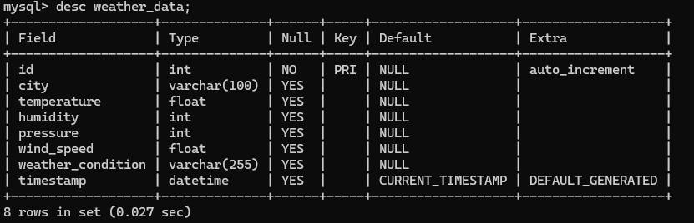
- search_history:
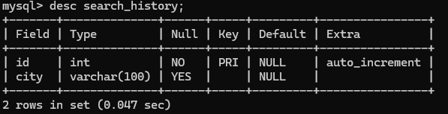

- forecast_data:
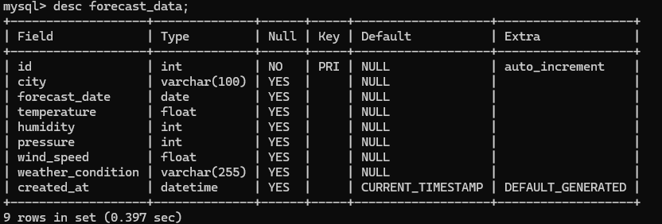

- Weather_alerts:
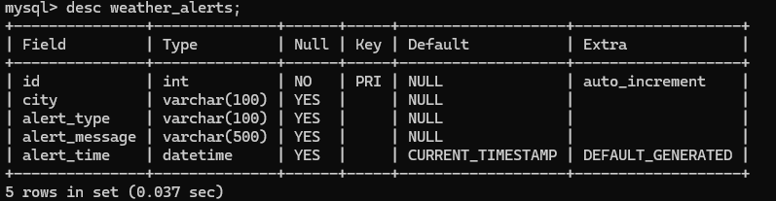

- pdf_reports: